**Sign Extension**

* Moving 2's complement integers between registers of different sizes is illegal without the sign extension operation.
* Sign-extending means copying the sign bit (MSB) of the unextended value to all bits on the left side of the larger-size value.
* For example, 8-bit encoding of decimal number -56 can be sign-extended as follows: 11001000 < 8-bit value of -56

11111111 11001000 < extended to 16-bit value

11111111 11111111 11111111 11001000 < extended 32-bit value

* Sign extending operation works positive values as well, provided the sign bit is zero:

01001000 < 8-bit value of 72

00000000 01001000 < extended to 16-bit value

00000000 00000000 00000000 01001000 < extended 32-bit value

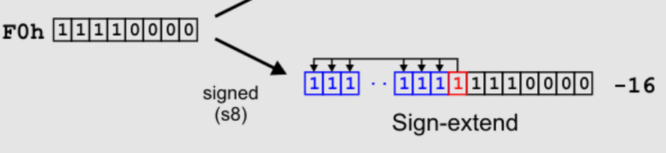

**Bits shifting**

**Logical Shift**

A Left Logical Shift of one position moves each bit to the left by one. The vacant least significant bit (LSB) is filled with zero and the most significant bit (MSB) is discarded.

A Right Logical Shift of one position moves each bit to the right by one. The least significant bit is discarded and the vacant MSB is filled with zero.

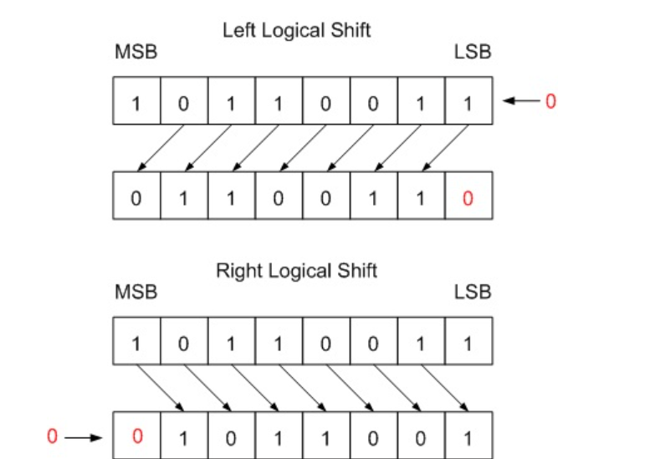

Arithmetic Shift

A Left Arithmetic Shift of one position moves each bit to the left by one. The vacant least significant bit (LSB) is filled with zero and the most significant bit (MSB) is discarded. It is identical to Left Logical Shift.

A Right Arithmetic Shift of one position moves each bit to the right by one. The least significant bit is discarded and the vacant MSB is filled with the value of the previous (now shifted one position to the right) MSB.

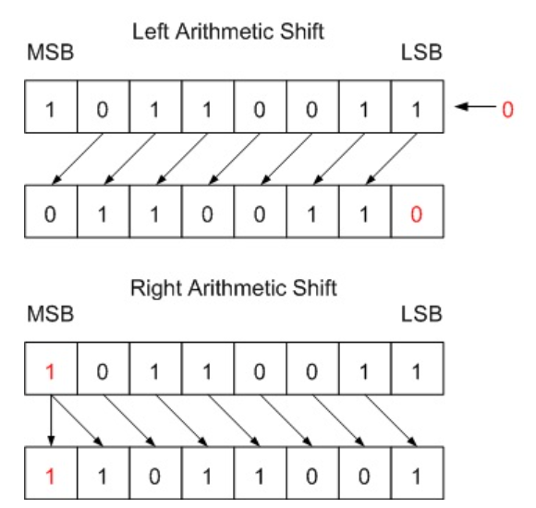

**Data memory**

Data memory (RAM)serves for storing and keeping data required for the proper operation of the programs

Data Memory will be a read-write memory which will store data. registers will be able to read data from data memory, and also store data to this memory

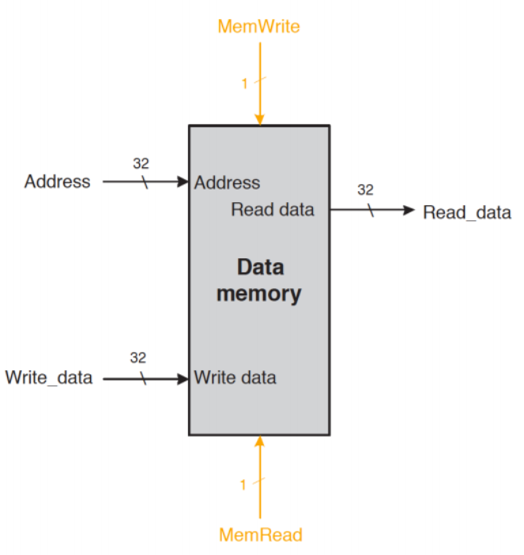

* Data memory performs load and store instructions
* Load instruction is used to load data from the register into data memory
* store instruction is used to write data into data memory
* single address input take care of both write and read operation
* both load and store operation cannot happen simultaneously
* external control signals (mem write/ mem read) are present which specifies whether read or write needs to be done